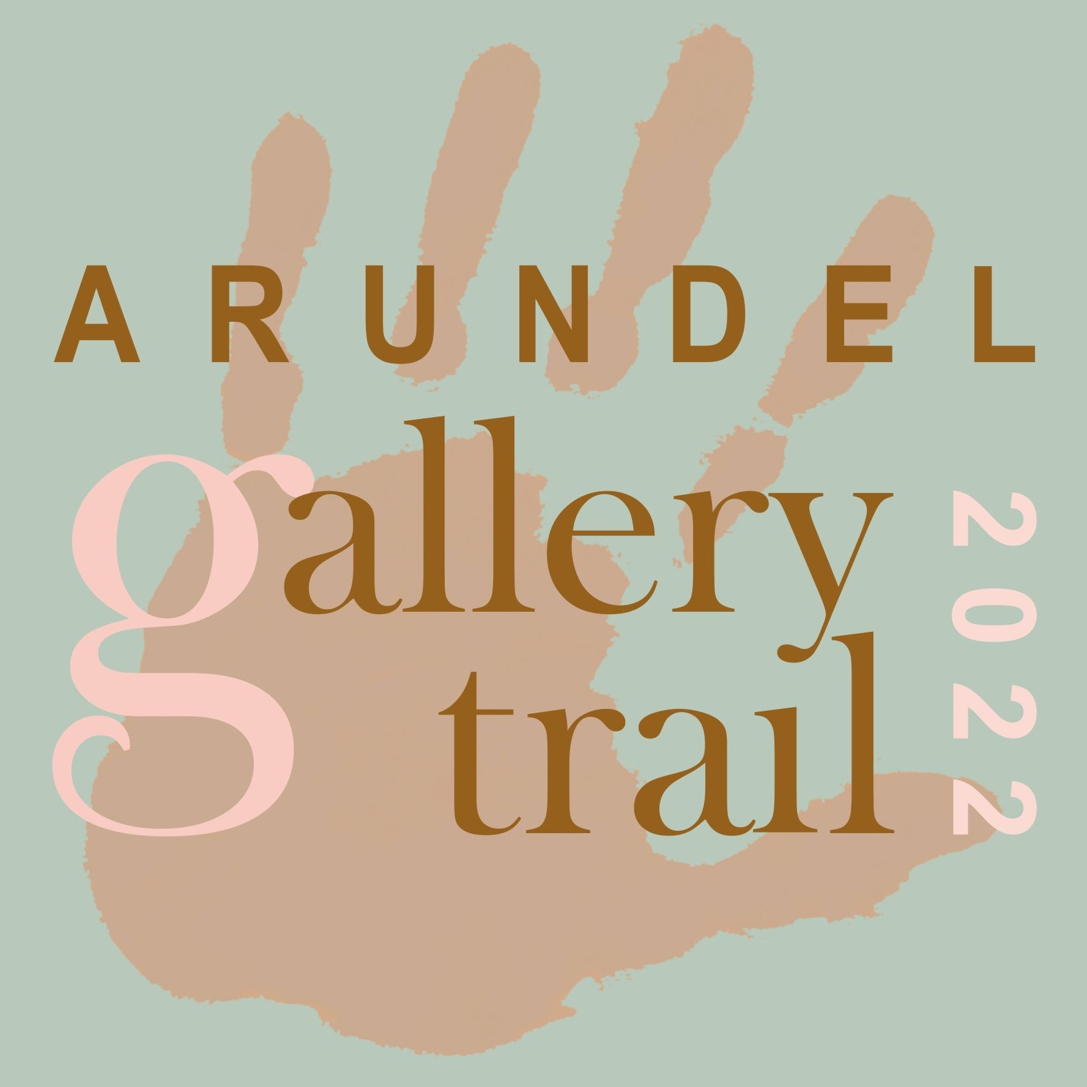
Exhibitor Registration 2022
Submit your registration by Friday 1st April 2022
*Important* - Incomplete forms cannot be accepted. Artist/Group Name …
Venue Address with post code …

Would you like to have the accessibility icon (disabled access) shown next to your venue listing? - Yes / No
Venue opening hours will be 12 noon to 5pm [minimum] Arundel Festival dates: Saturday 20 to Monday 29 August

Type of Work - please circle all applicable

Painting Sculpture Photography Ceramics Prints Jewellery Other (please specify)...
Please submit 4 images no smaller than 1 MB One of which in square format for the guide
and a separate studio shot of you at work

Fees/Payment

£75 - Individual Artist even if sharing a venue with others (non-refundable)
£250 - Group Fee for societies and galleries (non-refundable)

BACS transfer to Arundel Gallery Trail - Sort Code 60-01-18 a/c 67457746
Or cheque payable to Arundel Gallery Trail and returned to 54 Tarrant Street, BN18 9DN

Your Contact Details

Email ... Website …
Instagram … Facebook …
Mobile... Other...

Covid Regulation Compliance
We are required to participate in NHS Test and Trace at each Trail Venue.
By signing this Registration form you are agreeing that your venue will display a QR code and also will have a sign-in sheet available should visitors prefer.
All other Covid regulations in force at the time of the exhibition must be adhered to.

Sign and Date …
Return to - info@arundelgallerytrail.co.uk or 54 Tarrant Street, Arundel BN18 9DN

